Pass-the-Hash Attack Detection and Mitigation on Microsoft’s Active Directory

Daniel Rusev
Informational Technology
Lewis University
Romeoville, Illinois
danielgrusev@lewisu.edu

Hamza Khan
Informational Technology
Lewis University
Romeoville, Illinois
hamzahkhan@lewisu.edu

Abstract — The Pass-the-Hash attack poses a high security risk to organizations that utilize Microsoft Active Directory environments. The attack exploits a known vulnerability in Windows machines where hash values are cached in the memory of the Local Security Authority Subsystem Service (LSASS) process. The attack captures NTLM password hashes from the LSASS process and reuses a password hash to authenticate as a domain user account. This paper presents a detection system and mitigation product that aims to detect and counter known behaviors of a Pass-the-Hash attack. Our approach involves performing a simulation of a Pass-the-Hash attack in a Windows Active Directory environment, to highlight how an attacker can compromise a domain administrator’s NTLM hash and authenticate into the Active Directory’s Domain Controller with administrator privileges. We designed a detection pipeline using open-source tools such as Sysmon and Wazuh that detects and alerts administrators of specific Pass-the-Hash attack behaviors and attack sequences. Additionally, we implemented a set of mitigation practices that aim to reduce the vulnerabilities seen in Windows machines that allow for a Pass-the-Hash attack to exploit the LSASS process to gain password hashes. Our results show that organizations can leverage cost effective open-source detection tools to improve the detection of malicious Pass-the-Hash attack behaviors in their Active Directory environment. Additionally, our mitigation practices can significantly reduce the exposure of the exploitable vulnerabilities commonly seen in Windows environments.

Keywords — Pass-the-Hash attack, Active Directory, NTLM, Credential Theft, Lateral Movement, Wazuh, Sysmon, Mitigation

Introduction
Microsoft’s Active Directory is a service widely used among many IT infrastructures throughout the public and private sectors. Approximately, over 95% of Fortune 1000 companies use the Active Directory environment to manage their network resources, store the identities of their users and computer systems, and manage each user’s permissions and groups [1]. Active Directory relies on the Domain Controller server to keep detailed records of domain users, groups, and devices. These records play a key role in the Domain Controller’s ability to handle user authentication. When a user wants to authenticate a Windows machine located within the domain, the user’s credentials are sent to the Domain Controller for verification. After authentication, the Domain Controller authorizes users to access services on the domain, based on the domain policies that are applied to them [1]. Microsoft’s Active Directory relies on the Windows New Technology LAN Manager (NTLM) protocol to authenticate users’ identity onto the domain network using a set of hashed credentials. However, this design choice leaves many Active Directory environments extremely vulnerable to an attack known as the Pass-the-Hash attack. This is due to the Domain Controller caching its users’ NTLM credentials onto their device’s Local Security Authority Subsystem Service (LSASS) process [1]. With a Pass-the-Hash attack, attackers can leverage this vulnerability to impersonate as a legitimate Active Directory user by stealing their NTLM password hash stored in their device’s LSASS process. Hash values are then passed to the Domain Controller to authenticate as the domain user, allowing attackers to gain unauthorized access to the Active Directory domain. By gaining direct access to an Active Directory environment, attackers can escalate user privileges and move laterally across the domain to grant themselves full access to all the Active Directory’s services, and all the files that are located within the Domain Controller [1]. Although the Pass-the-Hash attack is prominent within Windows environments, detecting the attack behaviors is quite difficult as the attack can disguise itself as legitimate user authentication. As a result, detecting a Pass-the-Hash attack requires searching for specific abnormal events in each device’s event logs, and correlating them with each other to distinguish the attack’s behaviors from normal user activity.
This paper aims to address this issue by creating a two-tiered product that detects the evasive behaviors of the Pass-the-Hash attack and mitigates the vulnerabilities to prevent the compromise of the Active Directory’s data. Our detection method takes advantage of cost effective open-source tools such as Sysmon and Wazuh, to evaluate both tools’ effectiveness in detecting the specific behaviors associated with the Pass-the-Hash attack. We also employed various mitigation practices to evaluate the effectiveness of Windows environment defenses in preventing the exploitation of known vulnerabilities that allow credential harvesting, privilege escalation, and lateral movement to occur. To assess our two-tiered solution, we simulated a Pass-the-Hash attack on a vulnerable Active Directory environment by using a Kali Linux machine to attack a Windows 10 Pro machine that is connected to the Active Directory domain. The attack behaviors will be analyzed to study the artifacts it leaves after a successful attack on the Active Directory environment. Studying the attack artifacts will provide insight into building a strong foundation for our detection method that aims to alert administrators of suspicious activity that closely resembles a Pass-the-Hash attack. Our study of the attack also aims to identify the vulnerabilities exploited by the attack, to implement proper mitigation practices that prevent the Pass-the-Hash attack from compromising stored hash credentials. Ultimately, our research strives to contribute to a cost effective, yet practical two-tiered security system that enables Active Directory administrators to enhance their methods in detecting the subtle behaviors of a Pass-the-Hash attack. Our research also aims to improve the security of Windows environments, through enabling countermeasures that prevent credential harvesting, privilege escalation, and lateral movement.

Literature review

The Pass-the-Hash Attack and the Detection of its Behaviors
The following review of these pieces of literature explores critical concepts that cover the mechanics of what a Pass-the-Hash attack is, how it is performed, and the impacts it leaves on a production of Windows environment. Additionally, the review explores the implementation of open-source tools to detect Pass-the-Hash attack behaviors, and the application of frameworks such as the Indicators of Behavior model and the MITRE ATT&CK framework. These frameworks aim to validate the severity of specific attack behaviors and sequences.

What is a Pass-the-Hash Attack, How it is Performed, its Impacts, and How Open-Source Tools Can be Leveraged to Detect the Attack’s Behaviors: Felicite, Ayala-Rivera, & Portillo [1] identify how Microsoft’s Active Directory is widely used among corporate IT infrastructures and how its design is vulnerable to a Pass-the-Hash attack. They detail that a Pass-the-Hash attack exploits the common vulnerability of NTLM hashes being cached on the domain’s local devices’ LSASS process. This vulnerability allows an attacker to easily steal a user’s credentials to impersonate the user, and authenticate to the Domain Controller. Their study simulates a Pass-the-Hash attack in a virtual Active Directory environment that contains known vulnerabilities such as plaintext password exposure and disabled SMB signing. The simulation consists of scanning for target IP addresses, gaining remote access to the target Windows machine, escalating to administrator privileges through bypassing the User Account Control (UAC), and extracting a user’s NTLM credential hash from the LSASS process. They conclude the attack by compromising an administrator account that holds the highest level of privileges, to extract the NTDS.dit file containing all Active Directory data using the PsExec tool. The paper highlights that the attack is very difficult to detect as it does not generate specific events, and can appear as normal user activity. However, the attack does leave artifacts that can be leveraged by open-source detection tools to identify suspicious behaviors, such as the Command Prompt being launched by processes like fodhelper.exe, or successful remote logon events onto the Active Directory server. They utilized the Olaf Hartong’s System Modular configuration file that detects Pass-the-Hash artifacts such as processes being created, occurrences of remote authentication, and the accessing of domain files. Wazuh agents were deployed on each Windows machine to analyze logs from the Sysmon Event Channel, to send over to the main Wazuh server. The Wazuh server then triggers rules that alert when Pass-the-Hash events occur, such as the use of the PsExec tool, remote authentication using WinRM, and the fodhelper.exe process executing commands on the Command Prompt. This research paper is very valuable in describing the steps an attacker can take to perform a Pass-the-Hash attack on an Active Directory. This is useful in describing how to resimulate the attack on the environment for real-time analysis of its behaviors. The authors provided figures to show examples of the results of each step they took, and identified a handful of the artifacts left behind by the attack. However, while the paper demonstrates the effectiveness of Sysmon and Wazuh as detection tools, it lacks any false positive, true positive, and false negative rates that provide solid evidence towards the overall effectiveness of the detection system they put in place.

Indicators of Behaviors Model: Chetwyn, Eian, and Jøsang [2] describe how indicators can be divided into low-level, mid-level, or high-level behavior. While a low-level behavior by itself may not indicate a suspicious behavior, a chain of low-level and mid-level events can be inferred as a high-level behavior. The paper points out an advantage to this approach, as a detection model can send out alerts for general behavior, like user authentication, or highly suspicious behavior, like a non-administrator user successfully escalating privileges. The paper describes utilizing MITRE’s Caldrea platform to simulate malicious attacks on a network, and uses Olaf Hartong’s System Modular configuration file to generate Sysmon log events based on individual or grouped rule conditions. It provides a few examples of Sysmon rules that they implemented in their detection system to detect low-level behaviors chaining together. One such example is the low-level behavior of the PowerShell abnormally opening, being chained with the mid-level behavior of the “Mavinject.exe” file being executed. This paper points out that Sysmon is limited in specifically pointing out the true intention of the detected process; however, it explains that this issue can be solved with the Indicators of Behaviour framework. This framework indicates how detected low-level behaviors are chained together to signify that a malicious high-level behavior is taking place within the network. Parallels can be made with the Pass-the-Hash attack, as the attack does work by chaining multiple low-level events together to perform a high-level behavior. One such example is exploiting the fodhelper.exe process to bypass the UAC, which allows attackers to easily extract NTLM hashes from the LSASS process. This model can be efficiently used to create Wazuh rules that trigger when the chaining of low-level attack behaviors occur, indicating a specific attack sequence or high-level behavior.

Leveraging Wazuh Rules to Alert of Attack Behaviors: Asswad [3] describes how the Wazuh agent continuously sends out events to the Wazuh server for analysis and threat detection. It describes the different alert levels that Wazuh uses to understand the severity of triggered events. Examples include a level 3 showing a successful login attempt, requiring no human intervention, or a level 14 showing a high-importance security event, requiring immediate attention from a human. Wazuh separates rules into two categories, which are “atomic” and “composite”. An atomic rule describes a specific event that occurred without any correlation with another event. This can include simple authentication events or process openings. A composite rule describes repeated matches of one or multiple atomic rules within a specific timeframe. An example can include detecting multiple failed authentication events from the same user, occurring within a 120 second (about 4 minutes) timeframe. To display how Wazuh can detect and alert of attacks and vulnerabilities, the Asswad configures a Kali Linux and a Windows 8 virtual machine to simulate many different attacks such as an “Emotet malware” attack, and a “Log4shell” attack. While there were many attacks simulated for Wazuh to detect, our focus is more on using the Metasploit framework to conduct a Pass-the-Hash attack. While not related to a credential-stealing attack, Asswad does conduct a Drupalgeddon2 attack using the Metasploit framework. By leveraging this attack, Asswad configured a Wazuh rule that alerts administrators of any process that evaluates base64 code such as a new root user being added into the network. The results Asswad provided show a high success rate in detecting processes that evaluate base64 code. The concept of the Indicators of Behaviour framework from the previous paper can be applied in the design of composite rules, which can detect the chaining of multiple atomic rules within a short timeframe. However, this paper does lack details on how Wazuh can detect behaviors related to a Pass-the-Hash attack, such as privilege escalation or lateral movement behaviors.

MITRE ATT&CK Mapping: The Cybersecurity and Infrastructure Security Agency (CISA) [4] details how the MITRE ATT&CK framework can be leveraged to understand the what, how, and why of adversary behavior, and how the success of detecting cyberattacks depends on this understanding. The MITRE ATT&CK framework separates these behaviors into four glandular levels. The first level describes the tactics or the “why” of an ATT&CK technique. This represents the attack’s goals, the reasoning of the malicious action, and what the attack is trying to achieve. The second level describes the techniques or the “how” of an ATT&CK technique. This represents the specific behavior used to achieve a particular action or tactical goal. The third level describes the sub-techniques which highlights a specific method used to execute a broader technique. The fourth and final level describes the procedures or the “what” of an ATT&CK technique. This represents the specific tools, utilities or commands used by an adversary to achieve a certain technique or sub-technique. CISA introduces a few options of how raw data can be used to approach and map the MITRE ATT&CK framework based on the attack techniques used in the environment. Three options standout as the most relevant approaches to take in for our specific research on detecting Pass-the-Hash attack behaviors. The first option starts with a data source to identify the attack’s procedures and technique. This leverages tools that collect data logs from domain machines and networks such as Sysmon and Windows event logs. These data logs are used to identify the objects that the adversary is focusing on exploiting (files, processes, etc.), and also used to identify the action and techniques that were performed on the object. The second option starts with identifying the specific tool used to perform the procedures and techniques of an attack. This leverages event logs that identify the software and commands used by the adversary to perform an attack, and the specific file system components that the adversary accessed. The third option starts with detection analytics, usually implemented as rules within a security information and event management (SIEM) tool. A SIEM tool such as Wazuh collects a range of logs to identify malicious activity through analyzing a chain of events. This paper provides great value in explaining how the MITRE ATT&CK framework can be applied to provide a structure in how to detect and identify an adversarial behavior’s methods, tools that it used, and its ultimate goal. This is especially useful in identifying Pass-the-Hash attack behaviors, as the attack involves multiple stages of discrete actions that are difficult to identify its purpose and goal. Additionally, leveraging the data source approach can help point out processes and files that were exploited by the attack, which can aid in identifying what the specific behavior is and why the behavior occurred. The second approach is also a significant option to consider as an adversary can utilize software such as Mimikatz or the Windows command line to exploit processes such as fodhelper.exe. However, the third approach is likely the most significant option to consider as it identifies and correlates multiple low-level events that were chained together. This is relevant to the Pass-the-Hash attack because its methodology revolves around chaining a sequence of behaviors to ultimately compromise a NTLM hash.

Mitigation of Pass-the-Hash Attack Behaviors
The following review of these pieces of literature explores practical mitigation strategies that are essential in securing Active Directory environments against Pass-the-Hash attacks. These strategies explore methods of system and policy hardening, controlling user privileges, and isolating critical systems and networks from user devices.

System and Policy Hardening: MITRE [5] provides valuable information on the Pass-the-Hash attack. The article highlights core techniques and ways to mitigate the risk of this attack. It not only focuses on mitigation but also explains how the attack works and the mechanism behind it, discussing topics such as lateral movement and defense evasion. MITRE clearly shows why this attack is a critical threat in Windows Active Directory environments. MITRE also discusses real-world procedures and tools used in PtH attacks, such as Mimikatz and CrackMapExec, providing concrete examples that bridge theoretical knowledge and practical application. This information is essential for designing detection pipelines and lab experiments that realistically replicate attack scenarios. MITRE provides practical strategies to enhance system defenses against attacks, particularly Pass-the-Hash attacks. Key actions include enabling Credential Guard, securing LSASS memory, disabling WDigest, and limiting cached credentials. These steps offer effective methods to reduce the risk of such attacks. The article also emphasizes essential data sources and event logs, such as Windows Event IDs 4624, 4768, and 4769, which help detect suspicious login and authentication activity, such as the misuse of stolen hashes in Pass-the-Hash attacks. These logs serve as a strong foundation for developing detection analytics alongside proactive hardening measures (MITRE, 2025). It provides a clear understanding of how Pass-the-Hash attacks operate, including real-world techniques and tools. It also outlines practical mitigation steps, such as enabling Credential Guard and protecting LSASS memory, which can be implemented in the project environment to reduce risk.

Privilege and Access Management: The article provides valuable information on another aspect that is important in addressing the Pass-the-Hash attack, which is controlling account access to users in any network within an Active Directory. This limits attackers’ movement once they gain access. The SANS Institute [6] analyzes how to protect privileged domain accounts. This emphasizes the dangers of giving users more access than necessary. Pilkington recommends strict adherence to the Principle of Least Privilege, which supports the project’s plan to remove local admin rights from standard users and prevent credential-dumping attacks. Additionally, the SANS article Protecting Privileged Domain Accounts: Safeguarding Access Tokens highlights the critical role of Windows access tokens, which are digital representations of a user’s authentication and privileges used by the system to authorize actions. In Pass-the-Hash attacks, attackers can steal these tokens from memory to impersonate privileged accounts and move laterally across the network. The article provides practical guidance on securing tokens through system hardening techniques, such as implementing PoLP and using Group Policy, offering actionable strategies to mitigate PtH attacks effectively. This resource is useful while building the project because it emphasizes controlling account privileges to limit attackers’ movement within Active Directory. It provides guidance on implementing the Principle of Least Privilege by removing unnecessary admin rights, which helps reduce the risk of credential-dumping attacks.

Network Segmentation and Active Directory Protection: The NCC Group [7] emphasizes that protecting Active Directory (AD) requires securing the entire network, not just individual devices. Pass-the-Hash (PtH) attacks allow attackers to use stolen password hashes to authenticate without knowing the actual passwords [7]. The NCC Group article identifies network isolation as a key mitigation strategy, which involves separating critical systems from general user devices to prevent attackers from moving laterally across the network. Other recommended strategies include network segmentation to isolate sensitive systems further, using Restricted Admin Mode for RDP to prevent credentials from being propagated to other machines, and disabling NTLM authentication while relying on Kerberos, a secure authentication protocol that uses tickets instead of reusable password hashes, reducing the risk of PtH attacks. The article also highlights the importance of monitoring for unusual logon patterns, which helps immensely in detecting lateral movement [7]. These tools are incredibly useful in preparing and avoiding attacks before any loss of digital assets. This resource is helpful because it provides clear guidance on implementing network segmentation and Active Directory protections, which we can apply directly in our lab setup. It helps in designing isolated test environments, configuring Restricted Admin Mode for RDP, disabling NTLM, and setting up Kerberos authentication, allowing us to simulate and test Pass-the-Hash attack scenarios safely while practicing mitigation strategies [7].

System and Policy Hardening for Mitigation: Petri [8] provides a highly valuable resource on domain controller security, offering insights into system and policy hardening measures that can mitigate Pass-the-Hash (PtH) attacks. In his article, he details strategies for securing Domain Controllers, which are particularly useful for mitigating PtH attacks as they focus on enforcing least privilege for Tier-0 accounts and restricting logon rights, which are essential for reducing the risk of credential theft. The article also provides valuable information on Group Policy Objects (GPOs) linked to the Domain Controllers OU, removing unnecessary Remote Desktop access, and continuously monitoring Domain Controller (DC) logons [8]. These methods are effective for limiting the exposure of password hashes and other sensitive authentication material to potential attackers. Petri’s guidance supports strict access controls, role separation, and ongoing assessments, making it an essential reference for securing Active Directory against credential-based threats. It provides practical guidance on hardening domain controllers and implementing policies that can be applied directly in our lab environment. It allows the group to safely simulate Pass-the-Hash attack scenarios while testing and validating mitigation measures[8].

Methodology
In our experiment, we followed the Design Science Research Methodology (DSRM) approach presented by Vivian et al. [1], to design a vulnerable test environment to simulate and observe a Pass-the-Hash attack. Observations made during the simulation of the attack were used as a guide in the development of our detection pipeline, and mitigation products. Our methodology aims to address the question of how effective a custom detection pipeline can be at identifying Pass-the-Hash attack behaviors such as credential harvesting, privilege escalation, and lateral movement. Our research also examines the overall efficiency of mitigation practices that aim to prevent Pass-the-Hash attack behaviors from occurring within an Active Directory environment.

Test Environment Setup
Our test environment was set up using an isolated network of virtual machines running on a physical host machine. The test environment included four virtual machines that ran Kali Linux, Microsoft Windows Server 2019 Standard Evaluation with an Active Directory, Microsoft Windows 10 Pro client machine, and a Wazuh Server. Each virtual machine was hosted on the Oracle VirtualBox hypervisor that ran on a host machine containing an AMD Ryzen 5 5500U processor with a clock speed of 2.10 GHz and 16 GBs of RAM. We set up a fully isolated network using host-only adapters for each virtual machine, with the network built on top of a 192.168.56.x/24 subnet as shown in Figure 1.

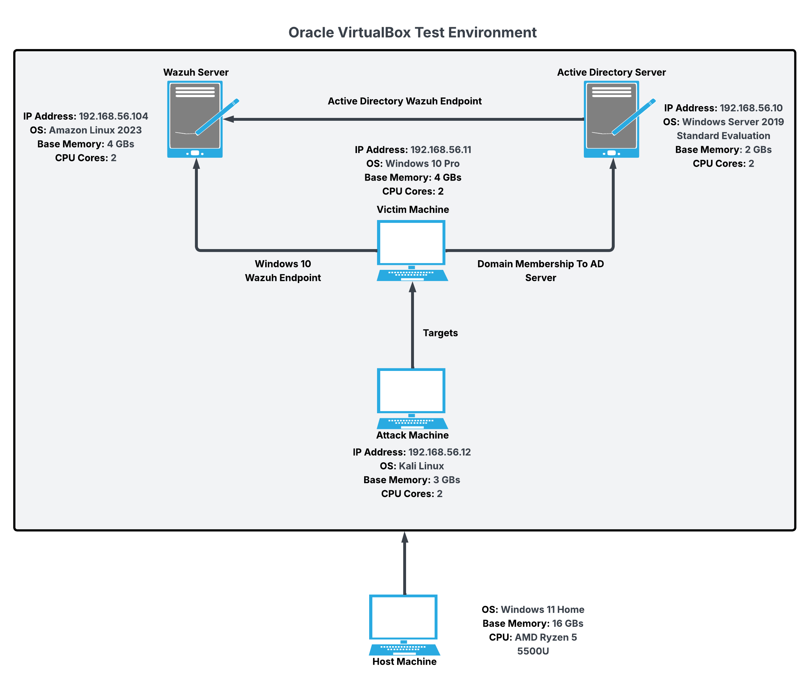
Fig. 1. Diagram of test environment showing each machine’s specifications and relationships with one another.

Active Directory Server: The Active Directory server was deployed on a Windows Server 2019 Standard Evaluation machine. A vulnerable Active Directory was created using the vulnad.ps1 script from the SafeBuffer GitHub project [9] to create users and groups while reproducing known security flaws, most importantly disabling Credential Guard features that leave the LSASS memory unguarded. We added a new user named Hamza Khan to the Active Directory who is part of the Domain Admins group and the Administrators group. This machine was configured with two CPU cores, two GBs of base memory, and an IP address of 192.168.56.10.

Attack Machine: The Kali Linux operating system was installed to act as the attack machine. Kali Linux houses several built-in penetration tools such as Metasploit, Nmap, and Kiwi that allow for us to perform network reconnaissance, escalate user privileges, dump NTLM credentials, and move laterally across the network. This machine was configured with two CPU cores, three GBs of base memory, and an IP address of 192.168.56.12.

Victim Machine: A Windows 10 Pro client machine was installed to act as the victim machine. This machine was configured with vulnerabilities such as disabled firewalls on the domain and private networks, and the “Real-time protection” option turned off. With these vulnerabilities configured, it allows us to download and run a malicious payload on the machine to perform the attack. This machine was configured with two CPU cores, four GBs of base memory, and an IP address of 192.168.56.11.

Wazuh Server: The Wazuh Server running Amazon Linux 2023 was configured as our detection system that alerts us when it detects Pass-the-Hash attack behaviors. This is done through collecting and analyzing Sysmon logs from Wazuh agents installed on both the Windows 10 Pro machine, and the Windows Server 2019 machine. This machine was configured with two CPU cores, four GBs of base memory, and an IP address of 192.168.56.104.

Pass-the-Hash Attack Simulation
Here, we executed each step of a Pass-the-Hash attack based on an altered approach outlined by Vivian et al [1] Our simulation followed four distinct stages to reach the end goal of compromising an administrator account and gaining complete control over the Domain Controller’s assets.

Reconnaissance Stage: We started our attack simulation by performing a reconnaissance of the network to identify machines to target for an attack. First, we used the Nmap tool to reveal all IP addresses inside the network using the -Pn argument, and revealed each IP address’ operating systems’ and open ports using the -A argument [10]. Combining these arguments led to Nmap revealing an IP address of 192.168.56.10 that has a 97% chance of running a Windows Server 2019 operating system. Nmap also revealed that 192.168.56.10 has port 389 open, which identified that the IP address is running an Active Directory server, with “cs.org” as its domain as shown in Figure 2.

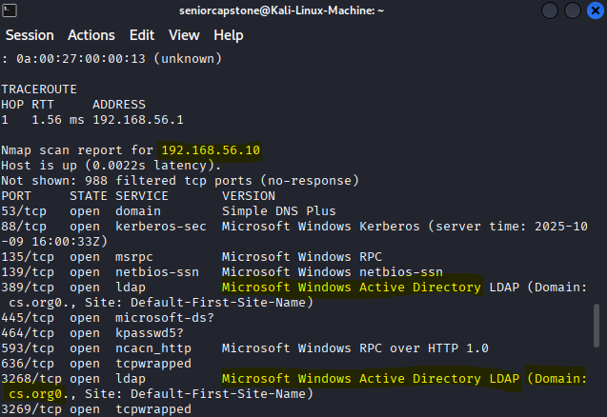
Fig. 2. The Nmap scan revealed a machine with the LDAP (389) port open. This port identified that the machine is hosting domain “cs.org”, which is an Active Directory.

The IP address of 192.168.56.11 has also been revealed as a Windows 10 machine, identifying a target that can potentially be a domain machine for the “cs.org” Active Directory. We experimented if we could first compromise a standard user account by listening for events on the network. The Responder tool was used to sniff for network events that involved user authentication. We tested this by having user Jobi Rois login to the Windows 10 Pro machine, and triggering a credential popup through typing “\\TestADServer” inside the File Explorer address bar. User Jobi Rois entered his credentials in the popup, and as a result Responder sent a poisoned answer and retrieved his NTLMv2 hash. We then tested if the hash could be cracked using the Hashcat tool [1]. Using the “rockyou” dictionary file, we were able to successfully crack user Jobi Rois’ NTLMv2 hash to reveal a password of “Password2025!”. This was one way of compromising a domain user’s account, however this method does not work when trying to compromise an account with administrator privileges. This is because Windows does not require an administrator account to enter in their credentials when attempting to access services on the domain. An administrator account needed to be targeted, as that account has the privilege to access the Domain Controller’s data. Fortunately, we were able to use a different approach that can compromise the NTLM hash credentials of an administrator account.

Obtaining Remote Access Stage: Since the reconnaissance stage revealed that the IP address of 192.168.56.11 is associated with a Windows 10 Pro machine, we set that machine as our target to obtain remote access to. To gain remote access to our target machine, we used Metasploit which is a penetration testing framework [1], to send a malicious payload to the Windows 10 Pro machine. The reconnaissance stage revealed that our target machine had several ports open using the TCP protocol. So we leveraged a TCP payload named “windows/x64/meterpreter/reverse tcp” to provide us a shell to interact with the target machine. To send the payload to the target machine, we used the MSFvenom [11] tool to generate the payload, and instruct it to connect the Windows 10 Pro machine to our Kali Linux attack machine. The command “sudo python3 -m http.server 80” was run to host the payload on a HTTP server, making the payload available to download on the target machine. On a separate terminal, the multi/handler module was configured to manage a reverse TCP connection to LHOST 192.168.56.12 and LPORT 1024. The primary function of the multi/handler module is to wait and listen for incoming connections from our payload once it is executed on a target machine [12]. On the target machine we logged in as user Hamza, and navigated to Microsoft Edge to enter in the URL “http://192.168.56.12/payload.exe”. Entering this URL downloads the payload directly onto the target machine. However, the Windows 10 Pro machine utilizes the Microsoft Defender Antivirus program to automatically scan for, and remove malicious files that are downloaded to the machine. To prevent our payload from being automatically removed, we added it as an exclusion that tells the Microsoft Defender Antivirus program to not scan the payload file for malicious content. Additionally, we disabled the “Real-time protection” setting to prevent the Windows 10 Pro machine from automatically stopping the execution of our payload. Once we altered the machine’s threat protection settings, we proceeded to execute the payload by clicking on the downloaded file. This successfully enabled the reverse TCP connection that the multi/handler module was listening for. Once the payload has been executed, a shell has been obtained, and a Meterpreter session has been opened, successfully establishing a remote connection from the attack machine to the target machine.

Privilege Escalation and NTLM Hash Extraction Stage: Once a remote connection has been established, we now aim to escalate our privileges, and move laterally across the network domain. To do this, we first must bypass the User Account Control (UAC) [13] security mechanism. This mechanism is designed to notify users when changes made to the system require administrator level privileges. Using the “bypassuac_fodhelper” exploit, we were able to leverage our payload into tricking the fodhelper.exe process into executing malicious commands with elevated privileges. This launched a second Meterpreter session which indicates that the UAC was successfully bypassed. After bypassing the UAC, we needed to identify the most recent account that logged into our target machine. We revealed this account by typing in “shell”, then “whoami” into the current Meterpreter session. With this command, Hamza was identified to have been the most recent user that logged into our target machine. Using the “net user Hamza/domain” command revealed that he is a part of the Domain Admin group, which indicates that he has administrator privileges. User Hamza was set as our target user to impersonate as, to gain access to the Domain Controller. Our next step is to retrieve Hamza’s hash from the device’s LSASS process to inject it into our current session, and grant us access to the Domain Controller. This was done using Metasploit’s Kiwi extension that has Mimikatz functionality. Mimikatz tools are used for extracting hashes, Kerberos tickets, and plaintext passwords [1]. By running the commands “kiwi_cmd privilege::debug”, then “kiwi_cmd sekurlsa::logonpasswords”, we were able to identify user Hamza’s NTLM hash as shown in Figure 3.

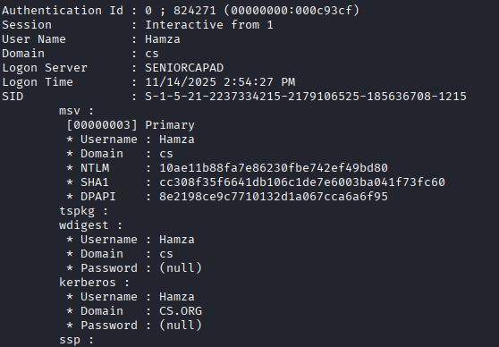
Fig. 3. Running the “kiwi_cmd sekurlsa::logonpasswords” revealed his NTLM hash stored in the local device’s LSASS process.

We used his hash alongside the kiwi_cmd sekurlsa::pth command to inject Hamza’s hash into the current session, which resulted in a Command Prompt window opening on the Windows 10 Pro machine. The Command Prompt window confirmed that we have successfully passed the hash, and impersonated Hamza on the target domain.

Remote Access to Domain Controller Stage: After obtaining user Hamza’s NTLM hash, our final objective is to gain remote access to the Domain Controller, and compromise the NTDS.dit file and SYSTEM registry hive. We initially tried to compromise these two files through using the PsExec tool to gain a remote connection to the Domain Controller, as demonstrated by Vivian et al [1]. However, the “Get-Bootkey” command used to extract the SYSTEM registry hive was not being recognized by the command line. This was due to the command only being recognized if the DSInternals PowerShell module is installed on the Active Directory server. We were unable to get that module installed, so instead we found a work around using the Evil-WinRM tool. Evil-WinRM is a tool that provides the attack machine an interactive shell to the Domain Controller [14]. Typing in the command “sudo evil-winrm -i 192.168.56.10 -u Hamza -H Hamza’s NTLM hash”, establishes a remote connection from the attack machine to the Domain Controller. After establishing a remote connection, we changed to the C:\Windows\NTDS directory to confirm that user Hamza has access to the NTDS.dit file. This file contains all of the Active Directory’s data, which includes users, groups, user permissions, and password hashes [1]. We then changed to the C:\Windows\System32\config directory to confirm that user Hamza also has access to the SYSTEM registry hive. This file contains the system boot key, which allows for the contents of the NTDS.dit file to be decrypted [1]. We changed to the temp folder that we created earlier on the Active Directory server, and then created a shadow copy of both the NTDS.dit and SYSTEM registry hive files [15]. Creating a shadow copy of each file allowed us to download each file’s copy directly onto the attack machine. After successfully downloading each shadow copy, we used the “impacket-secretsdump” command to decrypt the NTDS.dit file using the SYSTEM registry hive [16]. Once decryption of the NTDS.dit file is complete, the attacker has full access over the Domain Controller’s assets, including each domain users’ and administrators’ NTLM credentials as shown in Figure 4.
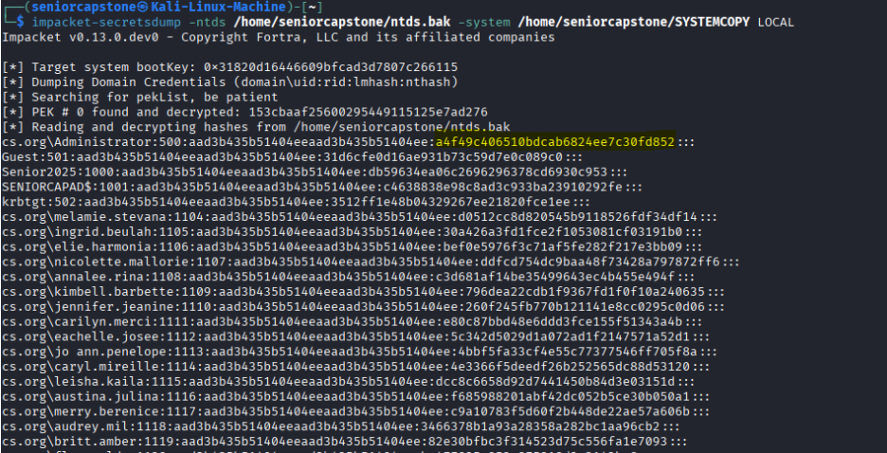

Fig. 4. Ran the “impacket-secretsdump” command to decrypt our copy of the NTDS.dit file using our copy of the SYSTEM registry hive. This revealed all user NTLM credentials, including the domain administrator’s credentials.

Detection Pipeline Objectives
After studying the attack behaviors, we implemented a total of thirteen rules that aim to detect and alert behaviors associated with the Pass-the-Hash attack. The following are the tools and rules we used to detect and alert Pass-the-Hash attack behaviors:

Sysmon: System Monitor (Sysmon) is a Windows system service that monitors and logs system activity, and records system activity to the Windows event log [17]. Sysmon generates events, each with their own ID, that categorizes the type of system activity being monitored. In our test environment, Sysmon was used to detect Event IDs that correspond with process creations (ID 1), network connections (ID 3), and process access (ID 10). Sysmon was installed with a custom configuration file [18] on both the Windows 10 Pro machine and Windows Server 2019 machine, designed to monitor security events that indicate behaviors of a Pass-the-Hash attack. This includes events that detect privilege escalation (ID 1), lateral movement (ID 3), and credential extraction (ID 10).

Wazuh: Wazuh is a security information and event management (SIEM) tool that collects data from log files, analyzes the timestamp, source, and data from each log message, and sends it to the security engineer to create immediate alerts of the event [3]. Wazuh consists of the Wazuh agent that is installed on both the Windows 10 Pro machine and Windows Server 2019 machine, to monitor Sysmon event logs and communicate those logs with the Wazuh Server. The Wazuh Server analyzes the logs received by the agents, matches it with a configured rule-set, and displays the alert to the user. We configured the Wazuh agent to monitor event logs using the Sysmon configuration file, and to monitor security-related operation events on the Microsoft-Windows-Security-Auditing channel [3]. In order for Wazuh to alert us of detected Pass-the-Hash attack behaviors, we have written a total of thirteen rules in the /var/ossec/etc/rules/local_rules.xml (custom rules) file. The first nine rules are our atomic rules, which are designed to detect specific low to medium-level behaviors associated with a Pass-the-Hash attack. These nine rules correlate with specific behaviors that we have observed while simulating the attack, such as the LSASS.exe process opening when we performed extraction of Hamza’s NTLM hash. The final four rules are our composite rules, which are designed to detect the chaining of these low to medium-level behaviors occurring within a thirty-minute timeframe. This approach aligns with the Indicator-of-Behavior concept, that identifies a higher level malicious behavior, when related low to medium-level behaviors are chained with each other [2]. We used this approach to write rules that triggered when we executed specific attack sequences, such as the sequence of bypassing the UAC, to then access the LSASS process for credential extraction.

Atomic Detection Rules (Rules 100000-100008): The first nine rules of our custom rules file are designed to detect specific individual behaviors that are associated with the Pass-the-Hash attack. Each rule is configured with one to two MITRE IDs, that follow a specific technique or sub-technique defined by the MITRE ATT&CK framework. The MITRE ATT&CK framework is leveraged as a knowledge base that provides details on the techniques and tools used by threat actors [4]. This framework identifies how and why specific behaviors have occurred, providing necessary context to develop effective rules that detect specific atomic behaviors. Each rule was configured with the MITRE’s data source approach to identify the specific techniques and sub-techniques used by an adversary, through using event logs collected by Sysmon [4]. This approach will identify the specific object (e.g., files, processes, or services) that the adversary focused on, and the action that was performed on the targeted object. Finally, each rule is linked to an already existing Sysmon rule that came pre-configured with the Wazuh Server. After deploying the Wazuh Server, we resimulated the attack to observe what pre-configured Sysmon rules are triggered by each step of the attack. We then gathered the most relevant rules that successfully detected Pass-the-Hash attack behaviors, and observed each event data field (e.g., image data, command line data, target file data, etc.) from the rule’s generated log as shown in Figure 5.

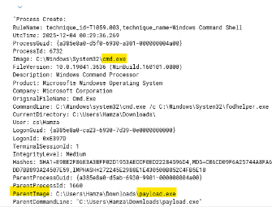
Fig. 5. Example log from Sysmon base rule “92052”. Here we observed that the “ParentImage” field contained an instance of our payload execution. The “Image” field contains an instance of the Command Prompt. These fields were used to create our own custom rule “100008”.

We then applied the most relevant event data fields for each of our own custom rules to detect the specific processes, commands, and files responsible for each attack step. This method is to ensure that our custom rules can detect the specific left over artifacts we observed during our simulation of the attack. Linking each base Sysmon rule serves the purpose of ensuring that our own custom rules can be triggered correctly. Wazuh will trigger the pre-configured rules instead of our custom rules if our custom rules lack a specific link to a base rule.

Rule 100000 - Detecting the Bypass of the UAC: The fodhelper.exe process was used to bypass the UAC in the attack simulation. To detect the use of the fodhelper.exe process, we configured a Wazuh rule in our custom rules file that will alert us when the process has been executed. To ensure that rule 100000 can be triggered, it is linked to rule 92046, which is a base Sysmon rule that identifies when the fodhelper.exe process was used to launch a command shell. Our own rule specifically uses the parent image data field to detect when the fodhelper.exe process has been opened. The rule also uses the image data field to detect when an elevated PowerShell session was used by the fodhelper.exe process to bypass the UAC as shown in Figure 6.

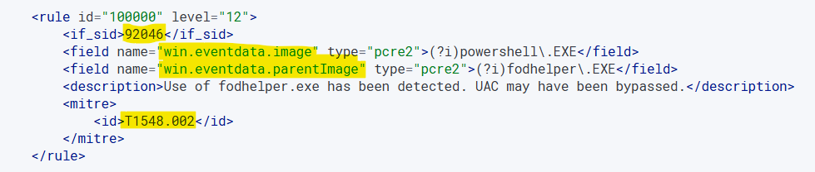
Fig. 6. Example of how our custom rules are structured. Each rule utilizes an event data field to identify a specific process, file, or executable that was used to perform a malicious action.

It is configured with an alert-level 12 [3] that indicates that a high-importance event has occurred within the system or network. Alert-level 12 was chosen for this rule, as the execution of the fodhelper.exe process is a high-importance event, due to it being the step that needs to be taken before an attacker can access the LSASS.exe process. This rule is configured with MITRE ID “T1548.002” [19], which is a sub-technique that helps identify when an attacker is bypassing the UAC to escalate privileges to administrator level, granting the attacker full control over the compromised target machine’s operating system.

Rules 100001 and 100002 - Detecting the Use of PsExec: In our attack simulation, we extracted the NTDS.dit and SYSTEM registry hive files through using the Evil-WinRM tool. This was to create shadow copies of those files to download straight to our Kali Linux machine. However, Sysmon was not able to create an event log that specifically detected the creation of the shadow copies we made of those two files. However, Sysmon was able to detect our failed attempt to use PsExec to attempt an extraction of those two files. We configured two rules in our custom rules file that will alert us when PsExec was used to open the Windows Server 2019 PowerShell, and when the PowerShell line contained “ntds.dit” and “SystemHiveFilePath”.

Rule 100001 is linked to rule 92068, which is a base Sysmon rule that detects when the PsExec service was executed on a command line. Our own rule uses the parent command line data field to detect the “PSEXESVC.exe” executable, and uses the image data field to detect when PsExec is executed on the Windows Server 2019 PowerShell. It is configured with an alert-level 3 [3] that indicates a successful/authorized event. This rule is labeled as a low-priority event as PsExec is commonly used for legitimate remote command execution by domain administrators. This rule takes advantage of MITRE ID “T1569.002” [20], which is a sub-technique that identifies when an adversary abuses the Windows service control manager or the PsExec tool to execute malicious commands.

Rule 100002 is configured to trigger when rule 92068 triggers, and is combined with the command line containing the specific strings “ntds.dit” and “SystemHiveFilePath”. This custom rule takes advantage of two command line data fields that detect instances of both the “ntds.dit” and “SystemHiveFilePath” strings being present on the command line. We increased the alert-level to a level 14 [3], that indicates a high-importance security event, as it signifies that a compromise of critical Domain Controller assets such as the NTDS.dit file is occurring.

Rules 100003 and 100005 - Detecting Remote Logon Using a NTLM Hash and the Evil-WinRM Tool: To reflect our use of the Evil-WinRM tool to create shadow copies of the NTDS.dit and SYSTEM registry hive files, we created two rules in our custom rules file that will alert us when the Kali Linux machine has gained remote access to the Domain Controller. Rule 100003 is linked to rule 92652, which is a base Sysmon rule that detects when an NTLM hash was used to authenticate onto a remote logon session. In our own custom rule, we utilized the authentication package name data field to detect when a NTLM authentication method was used to authenticate into the Domain Controller. The event ID data field was also utilized to specifically detect Windows Event ID 4624, which identifies a successful logon event. It is configured with an alert-level 6 [3], that indicates a low relevance attack as this event alone can be triggered by a legitimate authentication event, but could also potentially signal a highly suspicious authentication event. This rule takes advantage of MITRE ID “T1550.002” [5], which is a sub-technique that identifies the use of stolen password hashes to bypass standard authentication steps that require a cleartext password. It also uses MITRE ID “T1078.002” [21], which is a sub-technique that identifies when an adversary compromises a domain account with a high level of privileges, through means of credential dumping or password reuse.

Our second rule, rule 100005, is configured to detect the IP address of the machine that is using WinRM to remotely connect to the Domain Controller. This rule is linked to rule 92110, which is a base Sysmon rule that detects traffic from port 5985. Port 5985 is the port used by the WinRM protocol to allow users to interact with a remote system [22]. In our own custom rule, we used the destination port data field to identify when traffic goes through port 5985. We also used the destination IP data field to specifically detect when a machine remotely connects to the IP address of 192.168.56.10, which is the IP address assigned to the Windows Server 2019 machine. It is configured with an alert-level 6, as WinRM can be used legitimately by administrators to connect to the Domain Controller, but could also signal when a suspicious IP address has gained remote access to the Domain Controller. This rule takes advantage of MITRE ID “T1021.006” [22], which is a sub-technique that identifies when an adversary may have used a compromised domain account to remotely interact with other domain systems using the WinRM tool.

Rule 100004 - Detecting Credential Extraction: The LSASS.exe process was opened when we ran the “sekurlsa::logonpasswords” command [1] to extract Hamza’s password hash from the LSASS memory. To detect when there is an attempt to extract a user’s hash, we configured a rule in our custom rules file that will alert us when the LSASS.exe process has been opened. Rule 100004 is linked to rule 92900, which is a base Sysmon rule that detects when the LSASS.exe process was accessed with read permissions. In our own rule, we used the target image data field to specifically identify the execution of the LSASS.exe process. We also used the source image data field to identify that the LSASS.exe process was executed on the PowerShell to extract credential hashes. It is configured with an alert-level 14, as a successful execution of the LSASS.exe process confirms that there was an attempt to harvest credential hashes, which warrants an immediate investigation from a network administrator. This rule takes advantage of MITRE ID “T1003.001” [23], which is a sub-technique that identifies when an adversary attempts to access credentials that are stored in a domain device’s LSASS memory.

Rule 100006 - Detecting the Payload Execution: During our attack simulation, we sent and executed a malicious payload onto the Windows 10 Pro machine. Executing the malicious payload allowed the Kali Linux machine to gain remote access to our Windows 10 Pro target machine. We observed how Sysmon detected the malicious payload being executed on Hamza’s temp folder, and we have also observed that the malicious payload executed a myriad of PowerShell scripts to grant us remote access to the target machine. To detect when the malicious payload is executed, we configured a rule in our custom rules file that will alert us when a malicious file was executed on Hamza’s temp folder. Rule 100006 is linked to rule 92213, which is a base Sysmon rule that detects the file extensions (e.g., .exe, .msi, .dll, etc.) of a potentially malicious executable file being dropped into a user’s temp folder. In our own rule, we used the target file name data field to specifically detect PowerShell executable files (.ps1) being dropped into user Hamza’s temp folder. It is configured with an alert-level 14, as malicious files that are dropped into a Windows temp folder can indicate an established presence of an attacker, signaling their initial stage of compromise. This rule takes advantage of MITRE ID “T1105” [24], which is a technique that identifies when a malicious file or tool from an outside source has been transferred into the victim’s network and devices.

Rule 100007 - Detecting Reconnaissance of User Privileges: After bypassing the UAC, we performed reconnaissance of user Hamza’s privileges through running the “net user” command on the shell. To detect this reconnaissance of user privileges, we configured a rule in our custom rules file that will alert us when a recently executed command contains the line “net user” inside it. Rule 100007 is linked to rule 92039, which is a base Sysmon rule that detects when a net.exe account discovery command was initiated. In our own rule, we used the image data field to discover when the net.exe process has been executed on a domain machine. We also used the command line data field to detect instances of the string “user” being present on recently executed commands. It is configured with an alert-level 3, as account discovery commands are executed legitimately by Windows system tools, making this a low-priority event. However, this rule can still potentially indicate a performed reconnaissance of user privileges by an attacker. This rule takes advantage of MITRE ID “T1087.001” [25], which is a sub-technique that identifies when an adversary attempts to get a listing of user accounts by using commands such as “net user” and “net localgroup”, to identify each users’ privileges.

Rule 100008 - Detecting a Process Opening Up the Command Prompt: We have observed many instances of the Command Prompt being opened by other processes, such as with the fodhelper.exe process during the bypassing of the UAC. We also observed that the payload file was the original source that caused these processes to abnormally execute the Command Prompt. To detect when a process maliciously opens up the Command Prompt, we configured a rule in our custom rules file that will alert us when the payload file is the main cause in the abnormal execution of the Command Prompt. Rule 100008 is linked to rule 92052, which is a base Sysmon rule that detects when the Windows Command Prompt was started up abnormally by a process. In our own rule, we used the image data field to detect instances of the cmd.exe process being executed by another process. We also used the parent image data field to detect when the “payload.exe” executable was the original source that manipulated processes into opening up the Command Prompt. It is configured with an alert-level 6, as the execution of the Command Prompt by an abnormal process can indicate malicious behavior, but can also be triggered by domain administrators that are running processes that utilize the Command Prompt. This rule takes advantage of MITRE ID “T1059.003” [26], which is a sub-technique that identifies potential abuse of the command shell commonly invoked by batch files, such as our malicious payload.

Composite Detection Rules (Rules 100009-100012): Following the Indicator-of-Behavior concept [2], the last four rules of our custom rules file are designed to detect the chaining of low to medium-level behaviors that lead to a single high-level behavior. Each of these four rules combines two or more of the first nine rules together, to detect a specific attack sequence or step we executed during our simulation of a Pass-the-Hash attack as shown in Figure 7.

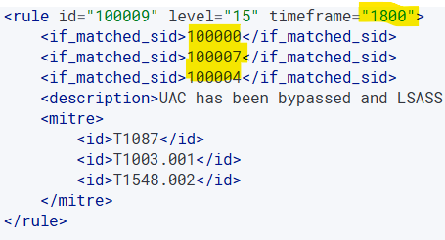
Fig. 7. Example of how our composite rules are built. Each composite rule must match the list of triggered atomic rules within a thirty-minute timeframe before it can be triggered itself.

Each rule is configured with an alert-level of 15 [3], indicating a severe attack that has successfully been executed on the Windows Server 2019 machine or on the Windows 10 Pro machine. These composite rules were configured with MITRE ATT&CK’s analytics approach [4], that identifies a chain of events through analyzing correlated event logs collected by Sysmon. This approach aims to correlate a chain of multiple low to medium-level behaviors, to identify a single high-level behavior that confirms the execution of a specific attack step we performed during our attack simulation.

Rule 100009 - Detecting Credential Harvesting: This rule is designed to detect the full attack sequence that led to the successful harvesting of credential hashes. This composite rule triggers when rules 100000, 100004, and 100007 have all been triggered within a thirty minute timeframe. The rule is designed to trigger when the UAC has been successfully bypassed (rule 100000), followed by a suspicious reconnaissance of user privileges (rule 100007), and ending with the attempt to access NTLM hashes stored within the LSASS memory (rule 100004). By correlating the chaining of these three rules, this composite rule aims to detect the full attack sequence we performed to compromise user Hamza’s NTLM hash.

Rule 100010 - Detecting a Suspicious Remote Logon to the Domain Controller: This rule is designed to detect the full attack sequence of passing an NTLM hash (rule 100003) to authenticate into the Domain Controller using the Evil-WinRM tool (rule 100005). This composite rule triggers when rules 100003 and 100005 have both triggered within a thirty minute timeframe. The rule is designed to detect when a malicious actor gains direct remote access to the Windows Server 2019 machine, and aims to confirm that malicious activity is taking place within the Domain Controller. This rule can indicate lateral movement across the domain, and signals a potential possibility of the Domain Controller’s sensitive data being extracted, through means of creating and downloading shadow copies of the NTDS.dit and SYSTEM registry hive files.

Rule 100011 - Detecting Extraction of NTDS.dit File Using the PsExec Tool: This rule is designed to detect the full sequence of steps taken to successfully compromise the Domain Controller’s assets through using the PsExec utility. This composite rule triggers when rules 100001 and 100002 have both triggered within a thirty minute timeframe. The rule is designed to detect when the PsExec service is opened on the Windows 10 Pro command line (rule 100001), to remotely execute a set of malicious commands onto the Windows Server 2019 machine (rule 100002), to extract the sensitive assets that contain all of the Active Directory’s data. By correlating the chaining of these two rules, this composite rule provides a direct alert for the targeted extraction of the NTDS.dit and the SYSTEM registry hive files. This aims to confirm the adversary’s intent to compromise the Active Directory’s assets contained within the Domain Controller.

Rule 100012 - Detecting Process Manipulation by the Payload: This rule is designed to detect the full sequence of behaviors that are associated with the execution of the malicious payload, that leads to a few processes abnormally executing the Command Prompt. This composite rule triggers when rules 100006 and 100008 have both triggered within a thirty minute timeframe. The rule is designed to trigger when the malicious payload has been executed on user Hamza’s temp folder (rule 100006), and successfully manipulates processes into executing commands on the Command Prompt (rule 100008). By correlating the chaining of these two rules, this composite rule aims to reveal the specific executable responsible for manipulating processes, reveal where the executable was dropped into, and reveal what processes were targeted.

Mitigation Practices Objectives
After identifying the specific behaviors associated with the Pass-the-Hash (PtH) attack, we implemented mitigation controls designed to limit credential reuse, strengthen local account security, and reduce the feasibility of unauthorized lateral movement [8]. The following mitigation practices were deployed to harden both the Windows 10 Pro machine and the Windows Server 2019 machine against PtH attack behaviors:

LAPS Effectiveness: Microsoft Local Administrator Password Solution (LAPS) was deployed to address a core weakness exploited during the initial Pass-the-Hash (PtH) attack: the presence of shared or static local administrator passwords across multiple domain-joined machines [27]. Because the attacker originally succeeded by reusing a single stolen NTLM hash to authenticate to multiple systems, LAPS was intentionally selected to eliminate this credential uniformity and enforce unique, automatically rotated local administrator passwords on every host.
Once LAPS was applied and the Windows 10 client processed the updated GPO configuration, the previously harvested NTLM hash immediately became invalid. Password rotation replaced the old credential stored in LSASS with a new, unrelated password that was securely written to the corresponding Active Directory attribute. When the attacker attempted to replay the stolen hash during post-mitigation testing, PsExec failed before establishing any remote connection, and no authentication request reached the Domain Controller. The absence of Event ID 4625 on the Domain Controller, combined with the presence of only a local Event ID 4624 [7] (Logon Type 9 NewCredentials), confirmed that the replayed hash did not match the rotated password and was rejected before domain-level validation could occur as shown in Figure 8 [5].

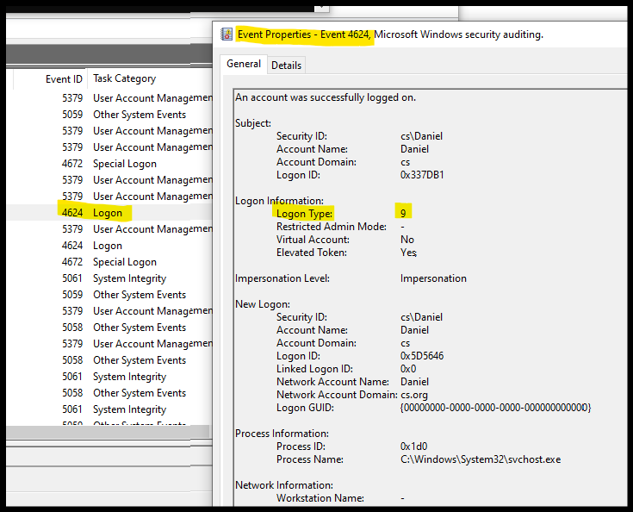

Fig. 8. Logon Type 9 (NewCredentials) Event showing PsExec-Initiated Local Logon with no remote authentication attempt.

To begin deployment, the LAPS installation package was installed on the Domain Controller to add the required administrative templates and PowerShell management tools [28]. These templates were imported into the Group Policy Central Store so that LAPS configuration options would be available when constructing the GPO. The Active Directory schema was verified to include the ms-Mcs-AdmPwd and ms-Mcs-AdmPwdExpirationTime attributes, which store the generated password and its expiration timestamp [28]. These schema attributes are essential because they serve as the secure storage mechanism that LAPS relies on to maintain password confidentiality within Active Directory.
A dedicated Group Policy Object titled “LAPS-LocalAdministratorPolicy” was then created and linked to the appropriate Organizational Units containing both the Windows 10 client and the Domain Controller. Within this GPO, password management was enabled and configured with a 14-character length requirement, enforced password complexity, and a daily expiration interval for testing purposes. Targeting the local Administrator account was also defined to ensure that only the correct account was being managed by the policy. These configurations, as shown in Figure 9, were applied to guarantee that the local administrator password would be rotated frequently and stored securely in AD [28].
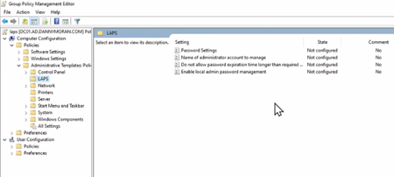

Fig. 9. LAPS Group Policy Object showing configured password management settings.

After the policy was created, the LAPS client component was installed on the Windows 10 machine so it could process the new password settings [29]. A forced Group Policy refresh (“gpupdate /force”) ensured that the workstation immediately applied the LAPS configuration [28]. When the policy took effect, the machine generated a brand-new randomized local administrator password and stored it in the appropriate Active Directory attributes. The rotation event and the newly assigned password were later verified through the LAPS UI and the ADUC attribute editor, confirming that LAPS was fully operational, as illustrated in Figure 10 [29].

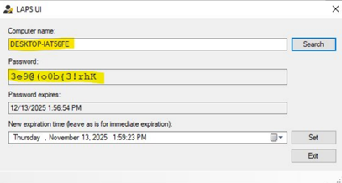

Fig. 10. Successful implementation of Microsoft LAPS showing the rotated local administrator password.

NTLMv2 Enforcement Effectiveness: Once NTLMv2 enforcement was applied, the system’s behavior during the re-simulated attack changed dramatically [30]. The previously harvested NTLM hash [6] could no longer be reused for remote authentication because NTLMv2 requires a dynamic challenge–response mechanism rather than accepting static hash replay. As a result, all attempts to authenticate to the Domain Controller using the stolen hash failed, and Event ID 4625 (failed logon) was consistently generated on the Domain Controller as shown in Figure 8. This directly demonstrated that the attacker’s original lateral movement path relying on traditional Pass-the-Hash techniques was no longer viable.

The overarching goal of NTLMv2 enforcement was to break the attacker’s ability to successfully replay stolen credentials for remote authentication. The results confirmed that this objective was achieved: although the NTLM hash could still be harvested from LSASS memory, it could no longer be used to establish a valid authentication session with domain resources. This fundamentally disrupts the Pass-the-Hash attack chain, which depends on the ability to reuse captured hashes across systems. However, one important limitation was also observed. NTLMv2 enforcement does not prevent credential harvesting itself; it only prevents successful hash reuse for authentication. Therefore, while NTLMv2 significantly strengthens domain authentication security and blocks traditional Pass-the-Hash replay attacks, it must be paired with additional mitigation such as Microsoft LAPS and credential protection features to fully reduce credential exposure.

Ethics of Our Research
Our Pass-the-Hash attack simulation was conducted within an isolated virtual environment using a pre-configured Active Directory that replicates known vulnerabilities. This is to ensure that our research does not exploit nor compromise production systems and their data or violate any computer protection laws such as the Computer Fraud and Abuse Act. Simulating this attack was strictly intended for observational research to study its left-over artifacts, behaviors, and generated event logs. These observations were critical in developing our detection and mitigation countermeasures, with the purpose of preventing a Pass-the-Hash attack in an Active Directory environment. Any unauthorized application of Pass-the-Hash techniques on real world systems is both extremely unethical and highly illegal.

Applications for Our Defensive Products
Our detection pipeline and mitigation products offer defensive value to organizations and cybersecurity professionals that need securing Active Directory servers or other environments that are vulnerable to the Pass-the-Hash attack. These defensive products are designed to enhance the security posture of network environments by enabling the detection, prevention, and response to threats present in the environment.

Detection Pipeline Product Application: Our detection pipeline product leverages free open-source tools, such as Sysmon and Wazuh, to detect and alert when Pass-the-Hash attack behaviors occur within a Windows environment. This was done through correlating event logs, and analyzing related system behaviors that appeared together within a short timeframe. Our detection pipeline can be applied in production networks to provide a cost effective, yet practical method of continuous monitoring of Pass-the-Hash attack behaviors. Our detection pipeline monitors in real-time for authentication activity, abnormal uses of the Command Prompt/PowerShell, processes opening suspiciously, and identification of chained behaviors that indicate a severe security event happening within the network. Our detection pipeline also provides the cybersecurity teams of these production networks real-time alerts of abnormal behaviors, allowing for immediate containment and response to the present threat. Immediate containment minimizes the time the threat can dwell within the environment, and limits the chance the threat has to escalate privileges and move laterally across the environment. Beyond production use, the combination of our test environment, attack methodology, and detection pipeline product provides a hands-on training platform for cybersecurity students and professionals to work on. This platform provides students and professionals an opportunity to practice network penetration on an isolated network environment, specifically by simulating a Pass-the-Hash attack. They can then observe the resulting security artifacts left over by the attack, the vulnerabilities that the threat exploited, and the correlated event logs and real-time alerts generated by the detection pipeline. Observations made by students and professionals can lead to a practical understanding of how a Pass-the-Hash attack or other related security events can be handled, contained, and responded to. Furthermore, observations of our work made by students and professionals can lead to applications of additional new rules that detect other Pass-the-Hash attack behaviors not covered in our original work. Moreover, our detection rules can also be applied by students and professionals to detect other related credential stealing attacks, such as a Pass-the-Ticket attack or a NTLM Relay attack.

Mitigation Product Applications: Our mitigation product provides practical defensive value for organizations that need to strengthen the security of their Active Directory environments against Pass the Hash attacks. The mitigation measures used in this project focused on Microsoft LAPS and the enforcement of NTLMv2 authentication. These two controls work together to reduce the chances of an attacker successfully reusing stolen NTLM hashes during lateral movement or privilege escalation attempts. Microsoft LAPS improves credential hygiene by automatically generating a unique local administrator password for every Windows machine and securely storing that password in Active Directory. When LAPS rotates these passwords on a scheduled interval, any previously captured local administrator hash becomes invalid. This directly limits an attacker’s ability to reuse compromised credentials across multiple systems, since each machine no longer shares the same local administrator password. In addition, storing the rotated password in a protected Active Directory attribute allows administrators to retrieve it when needed while maintaining strong access control over who can view it. Enforcing NTLMv2 authentication strengthens the domain by requiring a more secure challenge and response mechanism for authentication. NTLMv2 produces responses that are more resistant to replay, reducing the success rate of the traditional Pass the Hash technique. During our testing, once NTLMv2 was enforced, attempts to reuse captured NTLM hashes against the Domain Controller no longer resulted in successful authentication. This demonstrated that enforcing NTLMv2 changes how Windows processes NTLM based logons and prevents attackers from passing stolen hashes for remote authentication. Together, Microsoft LAPS and NTLMv2 enforcement create a practical defense that helps organizations reduce credential reuse and limit unauthorized lateral movement. These controls are simple to deploy in production environments, do not require specialized hardware, and can be applied through standard Group Policy configurations. They also provide an accessible learning opportunity in lab environments, allowing students and professionals to observe how enforcing strong authentication and rotating local administrator passwords changes the outcome of Pass the Hash attacks. Overall, the mitigation product provides a realistic and effective method for reducing the risk of Pass the Hash attacks in Active Directory environments. By rotating local administrator credentials and enforcing secure NTLM authentication, organizations can significantly limit an attacker’s ability to escalate privileges or compromise the Domain Controller. These mitigation practices offer a strong defensive foundation that can be expanded further with additional controls in future work.

Results
Here, we evaluated the overall performance of Sysmon and Wazuh in detecting and alerting of Pass-the-Hash attack behaviors in an Active Directory environment. We also evaluated the overall effectiveness of our mitigation practices in preventing these attack behaviors from exploiting Windows environment vulnerabilities. Each of our products' performances were assessed by performing three test runs of the attack on the Active Directory environment, and reviewing the outcomes of each attack step.

Detection Pipeline Outcomes

During our three test runs of the attack, we gathered all alerts that were generated by each rule, and calculated their true positive, false positive, and false negative rates using equations shown in Figure 11. Our true positive rates were calculated using the total number of generated alerts per rule, and comparing them against the alerts that were specifically generated during a known execution of a specific attack step. False positive rates were calculated using the total number of generated alerts per rule, and comparing them with the alerts that were generated by redundant events completely unrelated to the attack step we executed. Finally, false negative rates were calculated using the total number of generated alerts per rule, and comparing them with the number of true positive alerts that were not successfully generated during the execution of a specific attack step.

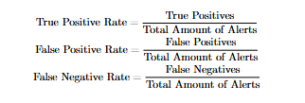
Fig. 11. Equations used to calculate the true positive, false positive, and false negative rates for each rule. Each percentage is rounded to the nearest tenth.

Success Rates of PsExec Rules: Rules 100001 and 100002 were both tested by resimulating the step to access the Windows Server 2019 PowerShell, to attempt an extraction of the NTDS.dit and SYSTEM registry hive files from the Domain Controller using the PsExec tool. Rule 100001 had the most success out of the two rules as it generated and displayed a total of three alerts on the Wazuh dashboard each time the PsExec process was opened. This rule achieved a 100% true positive rate based on the three test runs we made.

Rule 100002 successfully triggered as intended during the first run, when the phrases “ntds.dit” and “SystemHiveFilePath” were present on the command line. However, during our second and third test runs, rule 100002 did not trigger an alert, indicating a 66% false negative rate and a 33% true positive rate. This is due to rule 100002 being configured as the last rule needed to be detected before rule 100011 can be properly triggered. Since rule 100011 is configured as a composite rule, it is designed to override the second alert for rule 100002 on the second match, and instead trigger the first alert for rule 100011 [3]. Despite the apparent high false negative rate for rule 100002, this rule demonstrated that it can still effectively detect and alert when there is an attempt to extract the Domain Controller’s files using the PsExec tool. This is confirmed by the first true positive alert generated by rule 100002 during the first test run, and the two true positive alerts generated by rule 100011 in the second and third runs.

Success Rates of Remote Authentication Rules:
Rules 100003 and 100005 were both tested by re-simulating the step to pass the NTLM hash to successfully authenticate a remote session to the Domain Controller using Evil-WinRM. Rule 100003 successfully triggered as intended during the first run, when we used user Hamza’s NTLM hash to remotely authenticate onto the Domain Controller. However, in the second and third runs, rule 100003 generated two alerts in each of these two runs, resulting in five total alerts being generated. Three of them were true positives (60%), and two others were false positives (40%). This is due to the Windows Security event ID 4624 (Successful Logon) being generated twice during each creation of the second and third logon session. The Windows Security Log indicated this by showing two separate logon sessions occurring within seconds of each other. Event ID 4624 was generated twice due to it detecting each time we authenticated into the session, and each time we exited the session. This was observed in our second and third test runs as each time we exited WinRM to start a new test run, Wazuh would falsely generate an alert for a successful authentication event as shown in Figure 12.

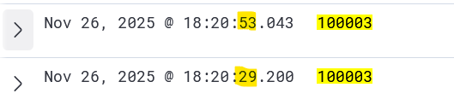
Fig. 12. After authenticating a remote session into the Domain Controller and exiting the session, rule 100003 generated two alerts within 24 seconds of each other.

However, despite these two false positive alerts, rule 100003 was still successful in detecting and alerting when NTLM authentication occurs, as indicated by the three true positive alerts generated during each test run.
Rule 100005 successfully triggered as intended during the first run, when we used the Evil-WinRM tool to authenticate a remote session to the Domain Controller. However, during our second and third test runs, rule 100005 did not trigger an alert, indicating an 80% false negative rate. This rule’s false negative rate is high, as it led its related composite rule (rule 100010) into generating two false positive alerts (40%) each time we exited during our second and third runs. Similar to rule 100003, this is due to rule 100005 detecting two distinct authentication events each time we logged in and out of the Domain Controller using WinRM. As rule 100005 was configured as the last correlation rule for rule 100010, rule 100010 ended up suppressing the two true positive and two false positive alerts generated by rule 100005. This resulted in the rule generating a high false negative rate of 80%, and only generating a true positive rate of 20%. Although rule 100005 did not generate alerts in the second and third run, this rule still demonstrated that it can effectively detect and alert when there is WinRM activity present on the Windows Server 2019 machine. This is confirmed by the first true positive alert generated by rule 100005 during the first test run, and the two true positive alerts by rule 100010 in the following two runs.

Success Rates of Reconnaissance and Credential Harvesting Rules: Rules 100000, 100004, and 100007 were all tested by resimulating the step to bypass the UAC, discover user privileges, and extract credential hashes using the Kiwi tool. Rule 100000 had the most success out of the three rules, as it generated and displayed a total of three alerts (100% true positive rate) each time the fodhelper.exe process was used to bypass the UAC.

Rule 100004 successfully triggered during the first run, when we extracted Hamza’s credential hashes using the Kiwi tool. However, similar to rules 100002 and 100005, rule 100004 was configured as the last rule needed to be triggered before an alert for rule 100009 can successfully trigger. After the second and third test runs, alerts for rule 100004 were suppressed to instead display alerts for rule 100009. This resulted in the rule having a true positive rate of 33%, but a false negative rate of 66%. Despite that, rule 100004 still demonstrated that it can effectively detect and alert when user credential hashes are being harvested from the LSASS.exe process. This is confirmed by the first true positive alert generated by rule 100004 during the first test run, and the two true positive alerts generated by rule 100009 in the following two runs.

Rule 100007 was designed with the intent to detect attempts to discover user privileges through running the “net user” command on the shell. However, this rule had the least success of all our custom rules, as it generated a total of ten alerts across our three test runs. Three of out the ten generated alerts successfully triggered during each run of using the “net user” command on the shell, indicating that it has a true positive detection rate of only 30%. However, each time we logged in as a user on the domain, a combined total of seven alerts were generated on both the Windows 10 Pro machine (four alerts), and the Windows Server 2019 machine (three alerts), indicating a false positive rate of 70%. We observed each of the false positive alerts on the Wazuh dashboard, and noticed that the Wazuh agents on both Windows machines were the ones responsible for these false positive alerts. Both Wazuh agents executed variations of the net user command, such as “net user guest” and “net user administrator”, on the command line when running the net.exe process as shown in Figure 13.

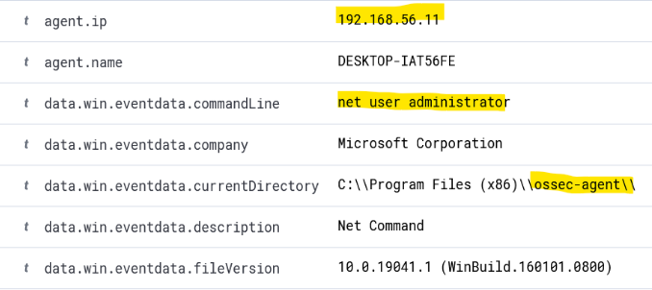
Fig. 13. Highlighted in the figure shows that the Wazuh endpoint agent runs net user commands each time the Windows 10 Pro machine starts up.

The high amount of false positive alerts indicates that this rule was configured too broadly, and needed to be properly tuned to exclude events triggered by the Wazuh agent endpoints.

Success Rates of Command Prompt Rules: Rules 100006 and 100008 were both tested by executing the payload on the Windows 10 Pro machine, and bypassing the UAC. Rule 100006 successfully triggered as intended during the first run, when the payload was executed on user Hamza’s temp folder, while manipulating the fodhelper.exe process into bypassing the UAC. However, rule 100006 triggered a total of six times during our three test runs, with only one of those alerts being a true positive (16.7%). Rule 100006 was configured as the last rule needed to be triggered before an alert for rule 100012 can be triggered. This led to the other five alerts registering as false negatives (83.3%) in the second and third run, as those alerts were suppressed by rule 100012. Three of those false negatives were due to rule 100012 being triggered three times after we executed the PsExec tool, during our three test runs of rules 100001 and 100002. We observed that PsExec drops its own executable PowerShell scripts into the temp folder, which matches rule 100006’s criteria of detecting executables containing a “.ps1” extension. The other two false negatives were a result of our other two test runs of this rule. Despite there being five false negatives, rule 100006 still demonstrated that it can effectively detect and alert when the payload’s PowerShell scripts are executed during attack sequences, such as when we bypassed the UAC. This is confirmed by the first true positive alert generated by rule 100006 during the first test run, and the two true positive alerts generated by rule 100012 in the second and third runs. While successful in detecting the payload’s execution, the rule still needs proper tuning to exclude events that were triggered by the PsExec tool.

Rule 100008 was unique in how it was triggered, as it was able to successfully generate twelve true positive alerts (100%) that captured the payload manipulating processes into executing the Command Prompt during the credential extraction stage of the attack. Three of those alerts captured the fodhelper.exe process opening the Command Prompt during each test run of the UAC bypass step. The remaining nine alerts captured the payload’s constant reconnaissance of the target user’s group membership, during the duration of the opened Meterpreter session, before the moment we bypassed the UAC. We came to that conclusion as we observed that the “whoami /groups” command was present in the command line event data field in the first nine generated alert logs as illustrated in Figure 14.

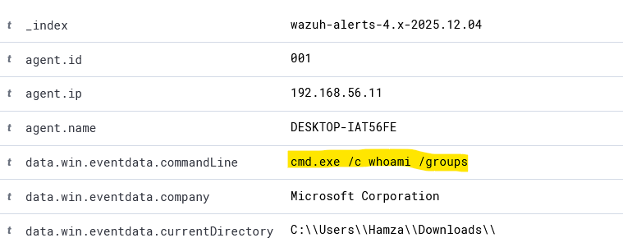
Fig. 14. Meterpreter was running the “whoami /groups” command when we were in the process of bypassing the UAC. Alerts for rule 100008 after bypassing the UAC, detected the fodhelper.exe process in the command line instead of the “whoami /groups” command.

Success Rates of Chaining Rules: Rules 100009-100012 did not initially trigger when its correlated rules were chained together within a thirty-minute timeframe. These rules only trigger when the last correlated rule triggers twice as seen with rules 100002, 100004, 100005, and 100006. This means that these composite rules will not trigger during the first execution of its related attack sequence, but rather will trigger after the second execution of the last rule in the sequence. This led to rules 100009-100012 overriding the alerts of the last correlated rule during the second and third test runs of the attack. As a result, rules 100009 and 100011 had a false negative rate of 33%, but a true positive rate of 66%.

However, rules 100010 and 100012 had different false negative and true positive rates, as both have triggered more than twice. Rule 100010 triggered a total of five times due to the WinRM authentication events from rule 100005 being generated four times during the second and third test runs. This gave rule 100010 a lower false negative rate of 20%, but also gave the rule a lower true positive rate of 40%, and a false positive rate of 40%. However, like with rules 100003 and 100005, rule 100010 was still successful in detecting the full remote authentication sequence, as indicated by the two true positive alerts it generated during the second and third remote authentication logins.

Rule 100012 triggered a total of five times due to PsExec falsely triggering the composite rule an additional three times as stated earlier. Since rule 100006 was the last rule needed to fulfill the correlation requirement, rule 100012 generated two true positive alerts that suppressed the second and third alerts for rule 100006 when triggered by the payload. This gave rule 100012 a lower false negative rate of 20%, but also gave the rule a lower true positive rate of 40%, and a false positive rate of 40%. While rule 100012 is effective in detecting the chaining of rules 100006 and 100008, it is being held back by rule 100006 being too broadly configured as it triggers alerts for all PowerShell script executions, including PsExec utilities.

Overall, while these correlation rules are effective in detecting the chaining of rules that indicate a stage of a Pass-the-Hash attack, they are not effective in triggering an alert on the first occurrence of an attack stage. Rules 100010 and 100012 are also slightly held back by its final correlation rules being either too broadly configured or events triggering at twice the rate, due to detecting both the authentication to session event and exit of the session event.

Mitigation Practices Outcomes
The effectiveness of Pass-the-Hash (PtH) techniques for lateral movement and privilege escalation was significantly curtailed by several implemented security measures. Specifically, the rotation of administrator passwords by LAPS invalidated previously captured hashes, preventing their reuse against the Domain Controller (DC). Furthermore, the enforcement of NTLMv2 reduced the success rate of NTLM authentication replay. Finally, restricting administrative privileges and segmenting the network with limited accessible attack paths.

LAPS Effectiveness: The implementation of Microsoft LAPS significantly changed the outcome of the Pass-the-Hash attack once the mitigation controls were applied. During the mitigation setup, a new Group Policy Object titled “LAPS-LocalAdministratorPolicy” was created and linked to the Organizational Units containing both the Windows 10 client machine and the Active Directory server. Within this policy, local administrator password management was enabled, the password length was set to fourteen characters, password complexity requirements were enforced, and a daily password rotation schedule was established for testing purposes. These configurations ensured that every time the GPO refreshed, the Windows 10 machine generated a new random password for its local administrator account, and this password was securely written to its corresponding Active Directory attribute. Once this policy took effect, the previously harvested NTLM hash of the local administrator could no longer be used to authenticate to any system in the domain. During post-mitigation testing, attempts to reuse the old hash through PsExec no longer resulted in a successful remote session, and the attack was blocked before a full NTLM authentication sequence could reach the Domain Controller. PsExec returned errors indicating that the remote share could not be accessed, and only a local logon event (Event ID 4624, Logon Type 9—NewCredentials, which indicates that PsExec created a local impersonation session without performing any domain authentication) was generated on the attacking machine, as shown in Figure 15 and Figure 16. No corresponding 4625 failed logon event was observed on the Domain Controller, confirming that the replayed hash was rejected prior to domain-level credential validation.

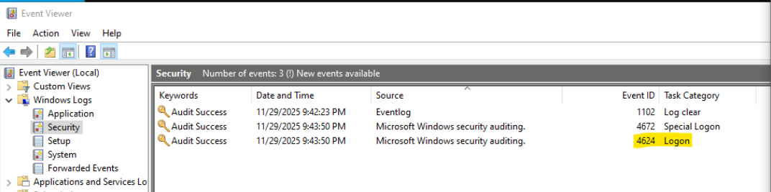

Fig. 15. Event ID 4624 (Logon Type 9) Showing PsExec Local Logon without remote authentication attempt.

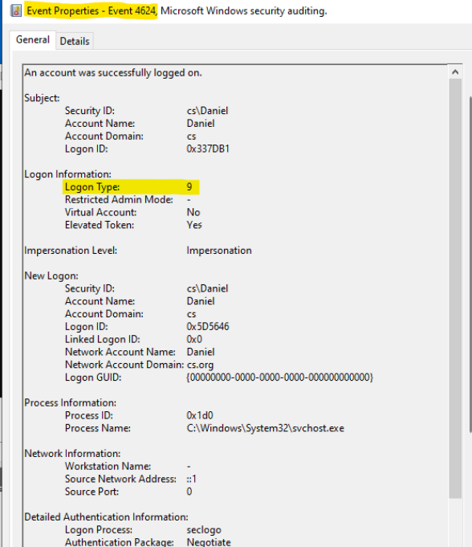

Fig. 16. Properties of Event ID 4624 (Logon Type 9) showing PsExec Local Logon without remote authentication attempt.

As a direct result, the attacker was unable to regain access to the Windows 10 Pro machine or pivot to additional hosts using the stolen local administrator hash, which prevented the lateral movement technique used in the first simulation. Because Pass-the-Hash attacks rely heavily on the reuse of static local administrator credentials across multiple machines, the rotation and central management enforced by LAPS effectively broke this attack path and forced the adversary to acquire new credentials for each host. Despite this strong protection, LAPS also revealed an important limitation. While it effectively protects local administrator accounts, it does not secure the domain administrator credentials stored in LSASS memory on the client workstation. If a domain administrator logs into a workstation, their NTLM hash may still be present in LSASS, meaning that an attacker with sufficient privileges could harvest and attempt to replay it. Thus, while LAPS was highly effective in stopping PtH movement based on local administrator accounts, additional measures are required to protect privileged domain-level tokens and prevent their extraction in the first place.

NTLMv2 Enforcement: The enforcement of NTLMv2-only authentication introduced another significant barrier to the attack progression. Before mitigation, the attacker successfully replayed the stolen administrator NTLM hash to authenticate to the Domain Controller through tools such as PsExec and Evil-WinRM. To prevent this, a second Group Policy was configured to modify the LAN Manager authentication level. The policy was set to “Send NTLMv2 response only” and “Refuse LM and NTLM,” forcing all systems within the domain to reject legacy authentication protocols and accept only NTLMv2. Once the NTLM hardening policy was applied and the machines refreshed their GPO settings, the attacker’s attempts to authenticate using the stolen NTLM hash failed across all tools. PsExec, which had previously established a remote session with the Domain Controller during the initial attack, could no longer authenticate using the captured hash. The Domain Controller rejected the authentication attempt and produced errors consistent with NTLM refusal. Similarly, when attempting to reconnect using Evil-WinRM, the attacker was consistently denied access with authentication failures. These failures were further supported by the presence of Event ID 8004 in the security logs, confirming that NTLM-based authentication had been blocked at the policy level. The underlying reason for this failure is that NTLMv2 relies on dynamic challenge-response structures containing session-specific values, meaning that a static NTLM hash captured from LSASS memory cannot generate a valid response. As a result, enforcing NTLMv2 prevented hash replay attempts regardless of whether the attacker possessed a valid NTLM hash. This change effectively removed the attacker’s ability to impersonate domain administrators, perform remote authentication, or move laterally through NTLM-based tools.

Combined Impact on the PtH Attack Chain: When Microsoft LAPS and NTLMv2 enforcement were applied together, the attacker’s ability to progress through the Pass-the-Hash attack chain was significantly diminished. Credential harvesting remained technically possible, as the attacker could still extract NTLM hashes from LSASS. However, the stolen local administrator hash was rendered useless because LAPS had already replaced it with a new randomly generated credential. At the same time, the stolen domain administrator hash could not be used for remote authentication because NTLMv2 made hash replay ineffective. The combined effect of these policies halted multiple stages of the PtH attack. Without reusable credentials, lateral movement from the compromised Windows 10 machine was no longer possible. Remote authentication attempts to the Domain Controller including those needed to extract the NTDS.dit file or SYSTEM registry hive were consistently rejected. Privilege escalation paths reliant on NTLM-based replay were effectively neutralized, and the attack sequence was unable to progress to the final stages involving domain compromise. These findings demonstrate that preventive controls meaningfully reduce PtH attack viability by removing the attacker’s ability to reuse compromised credentials. Unlike detection-only approaches, LAPS and NTLMv2 enforcement directly interrupt the mechanisms that enable credential-theft-based attacks. As a result, the mitigation configuration proved to be an essential component in safeguarding the Active Directory environment, and the combination of both controls created a significantly stronger security posture than either measure would have achieved individually.

Conclusion
Our project studies and investigates the process of a Pass-the-Hash attack compromising a Windows Active Directory environment, and the overall effectiveness of open-source tools in detecting and mitigating behaviors of a Pass-the-Hash attack. By simulating the attack, we demonstrated that an attacker could leverage Pass-the-Hash techniques to discover potential machines to target, deploy a malicious payload to gain remote access to the target machine, and exploit the UAC to escalate privileges in the network. The demonstration of privilege escalation presented a critical opportunity for an attacker to harvest a domain administrator’s NTLM password hash from the LSASS.exe process, leading to a successful impersonation of the domain administrator, and gaining full control over the Domain Controller.

Detection Pipeline
While leveraging both Sysmon as an event monitoring tool and Wazuh as a SIEM tool, we demonstrated that these open-source tools can be reliably used to detect and alert Pass-the-Hash attack behaviors that are present in an Active Directory environment. Using generated logs and correlating related events, we were able to create a pipeline that successfully detected key Pass-the-Hash indicators. Our detection pipeline successfully detected privilege escalation through bypassing of the UAC, credential extraction through suspicious creation of the LSASS.exe process, and lateral movement through remote authentication using an administrator’s NTLM hash. Additionally, by writing rules that combine key indicators, we were able to demonstrate that the chaining of related behaviors can accurately identify specific steps of a Pass-the-Hash attack. This successfully detected specific attack sequences that include the credential harvesting process, extraction of sensitive Active Directory files, and use of the malicious payload. However, our detection pipeline encountered a few limitations in its initial implementation. A significant challenge was the high rate of false positives observed in rules 100003, 100005, 100006, 100007, 100010, and 100012. These rules generated false positive alerts due to being triggered by rapid authentication events, Wazuh endpoint processes, and normal execution of the PsExec tool. Additionally, we faced a challenge with our chaining rules, where the rules did not trigger on the first instance of an attack sequence. Instead, these rules would trigger on the second instance of an attack sequence and beyond, resulting in all composite rules having a false negative rate of 33% or above.

Mitigation Practices
The mitigation component of our project demonstrated that even a small set of targeted controls can significantly reduce the effectiveness of Pass the Hash attacks within an Active Directory environment. The use of Microsoft LAPS and the enforcement of NTLMv2 authentication provided measurable improvements in preventing the reuse of captured NTLM hashes during lateral movement attempts. By rotating the local administrator password on each client system, LAPS ensured that previously harvested hashes no longer offered viable authentication paths. This directly limited the attacker’s ability to move from the compromised Windows 10 machine to the Domain Controller, since the hash obtained during the attack simulation was valid only for a short period of time. Enforcing NTLMv2 further strengthened the environment by requiring a more secure challenge and response mechanism for authentication. This prevented the attacker from reusing the stolen NTLM hash to authenticate remotely to the Domain Controller, which was a critical step in the original attack sequence. The primary benefit of the mitigation product is its simplicity and effectiveness. Both LAPS and NTLMv2 enforcement rely on native Windows features and require no additional software beyond what is already included in most enterprise environments. This makes the mitigation strategy easy to adopt and scalable across different organizations. Furthermore, these controls can be deployed through Group Policy, allowing administrators to secure large networks with minimal operational complexity. The changes made by these policies directly impacted on the attack workflow in our simulation, showing a clear reduction in the attacker’s ability to escalate privileges or compromise administrative assets. However, the mitigation product does have limitations that were observed during testing. While LAPS prevents an attacker from reusing a local administrator hash, it does not protect domain credentials that may still be cached in the LSASS.exe process. Also, enforcing NTLMv2 does not eliminate the use of NTLM entirely, and environments that rely on older systems or legacy applications may face challenges in fully adopting NTLMv2. Another limitation is that LAPS primarily protects local administrator accounts and does not address misconfigurations in domain administrator privileges or other privileged groups. These gaps illustrate that the mitigation product is effective for reducing key vulnerabilities, but additional policies and hardening techniques would be required to achieve full protection against credential theft and lateral movement. Overall, the mitigation product successfully demonstrated that enforcing NTLMv2 authentication and rotating local administrator passwords with LAPS can significantly reduce the impact of Pass the Hash attacks in an Active Directory environment. These controls limited the attacker’s capabilities, prevented successful reuse of stolen credentials, and strengthened the overall security posture of the environment. The results of this project show that even fundamental security controls can create meaningful barriers against powerful credential-based attacks, and they form a strong foundation for future work that focuses on expanding hardening measures, enhancing access control policies, and integrating additional protections for domain level accounts.

Further Research
Further research for our work should explore fine tuning our custom rules to reduce false positive rates, and have the rules differentiate normal user and system activity from genuine attack behaviors. Additional research should also explore solutions to reduce the false negative rates, eliminate suppression of last chained atomic rule, and ensure that the composite rules reliably trigger on the first instance of an attack sequence. Furthermore, future research should also explore extending the scalability and performance of our detection and mitigation products to include countermeasures focused on reconnaissance, preventing the downloading of malicious files to the network, and using a remote session to create shadow copies of critical files. Finally, future research should embrace training machine learning models to improve our products, using left over attack artifacts and event logs as a dataset. This can cause the creation of an adaptive security system that can efficiently filter out false positive rates, effectively differentiate normal system and user activity from malicious activity, continuously learn and adapt to evolving Pass-the-Hash techniques, and quickly react and respond to detected threats. In addition to detection improvements, the mitigation component of this work can be expanded by exploring additional Active Directory hardening techniques beyond Microsoft LAPS and NTLMv2 enforcement. This includes studying the effectiveness of Credential Guard, Protected Users groups, stricter Kerberos-only authentication policies, and advanced privileged access management solutions. Further testing should evaluate how these controls perform against more advanced credential-theft techniques such as NTLM relay and Pass-the-Ticket attacks. Expanding mitigation research in this direction would help strengthen domain-level account protection and further reduce the attack surface of Active Directory environments.

References
- J. G. Vivian Felicite, V. Ayala-Rivera, and A. O. Portillo-Dominguez, “Detecting Pass-the-Hash Attack in a Microsoft Active Directory Environment using an Open-Source Approach,” 2024 12th International Conference in Software Engineering Research and Innovation (CONISOFT), pp. 175–184, Oct. 2024, doi: https://doi.org/10.1109/conisoft63288.2024.00031.
- R. A. Chetwyn, M. Eian, and Audun Jøsang, “Modelling Indicators of Behaviour for Cyber Threat Hunting via Sysmon,” pp. 95–104, Jun. 2024, doi: https://doi.org/10.1145/3655693.3655722.
- ‌A. Asswad, F. Gringoli, and N. Pasquarè, “Analysis of attacks and prevention methods in cybersecurity,” Thesis, Univ. Brescia, 2022, pp. 15–17, 47–50, 74–75. [Online]. Available: https://ans.unibs.it/assets/documents/thesis/Thesis_Annas_Asswad.pdf (accessed Dec. 6, 2025).
- Cybersecurity and Infrastructure Security Agency, “Best practices for MITRE ATT&CK mapping,” 2023. [Online]. Available: https://www.cisa.gov/sites/default/files/2023-01/Best%20Practices%20for%20MITRE%20ATTCK%20Mapping.pdf (accessed Dec. 6, 2025).
- MITRE ATT&CK, “Use alternate authentication material: Pass the hash (T1550.002),” Jan. 30, 2020. [Online]. Available: https://attack.mitre.org/techniques/T1550/002/ (accessed Dec. 6, 2025).
- M. Pilkington, “Protecting privileged domain accounts: Restricted admin and protected users,” SANS Institute, Nov. 13, 2014. [Online]. Available: https://www.sans.org/blog/protecting-privileged-domain-accounts-restricted-admin-and-protected-users (accessed Dec. 6, 2025).
- “Defending your directory: An expert guide to mitigating pass-the-hash attacks in Active Directory,” NCC Group, 2025. [Online]. Available: https://www.nccgroup.com/research-blog/defending-your-directory-an-expert-guide-to-mitigating-pass-the-hash-attacks-in-active-directory/ (accessed Dec. 6, 2025).
- D. Petri, “AD security 101: Domain controller security,” Semperis, May 5, 2023. [Online]. Available: https://www.semperis.com/blog/ad-security-101-domain-controller-security/ (accessed Dec. 6, 2025).
- SafeBuffer, “vulnerable-AD: Create a vulnerable Active Directory for testing attacks,” GitHub, 2025. [Online]. Available: https://github.com/safebuffer/vulnerable-AD (accessed Oct. 3, 2025).
- Nmap, “Options summary,” Nmap.org, 2019. [Online]. Available: https://nmap.org/book/man-briefoptions.html (accessed Dec. 6, 2025).
- OffSec, “MSFvenom - Metasploit Unleashed,” OffSec, 2025. [Online]. Available: https://www.offsec.com/metasploit-unleashed/msfvenom/ (accessed Dec. 6, 2025).
- OffSec, “Binary payloads - Metasploit Unleashed,” OffSec, 2025. [Online]. Available: https://www.offsec.com/metasploit-unleashed/binary-payloads/ (accessed Nov. 10, 2025).
- Microsoft, “User Account Control,” May 31, 2023. [Online]. Available: https://learn.microsoft.com/en-us/windows/security/application-security/application-control/user-account-control/ (accessed Dec. 6, 2025).
- Kali Linux, “evil-winrm,” [Online]. Available: https://www.kali.org/tools/evil-winrm/ (accessed Dec. 6, 2025).
- A. Trexler, “AD series: Using Evil-WinRM to get NTDS manually in penetration tests,” Raxis, Mar. 11, 2025. [Online]. Available: https://raxis.com/blog/ad-series-using-evil-winrm-to-get-ntds-manually/ (accessed Nov. 10, 2025).
- Linux Command Library, “impacket-secretsdump,” 2025. [Online]. Available: https://linuxcommandlibrary.com/man/impacket-secretsdump (accessed Nov. 11, 2025).
- M. Russinovich, “Sysmon - Windows Sysinternals,” Jul. 23, 2024. [Online]. Available: https://learn.microsoft.com/en-us/sysinternals/downloads/sysmon (accessed Dec. 6, 2025).
- O. Hartong, “sysmonconfig.xml,” GitHub. [Online]. Available: https://github.com/olafhartong/sysmon-modular/blob/master/sysmonconfig.xml (accessed Dec. 6, 2025).
- MITRE ATT&CK, “Abuse elevation control mechanism: Bypass user account control (T1548.002),” [Online]. Available: https://attack.mitre.org/techniques/T1548/002/ (accessed Dec. 6, 2025).
- MITRE ATT&CK, “System services: Service execution (T1569.002),” [Online]. Available: https://attack.mitre.org/techniques/T1569/002/ (accessed Dec. 6, 2025).
- MITRE ATT&CK, “Valid accounts: Domain accounts (T1078.002),” [Online]. Available: https://attack.mitre.org/techniques/T1078/002/ (accessed Dec. 6, 2025).
- MITRE ATT&CK, “Remote services: Windows Remote Management (T1021.006),” [Online]. Available: https://attack.mitre.org/techniques/T1021/006/ (accessed Dec. 6, 2025).
- MITRE ATT&CK, “OS credential dumping: LSASS memory (T1003.001),” [Online]. Available: https://attack.mitre.org/techniques/T1003/001/ (accessed Dec. 6, 2025).
- MITRE ATT&CK, “Ingress tool transfer (T1105),” [Online]. Available: https://attack.mitre.org/techniques/T1105/ (accessed Dec. 6, 2025).
- MITRE ATT&CK, “Account discovery: Local account (T1087.001),” [Online]. Available: https://attack.mitre.org/techniques/T1087/001/ (accessed Dec. 6, 2025).
- MITRE ATT&CK, “Command and scripting interpreter: Windows command shell (T1059.003),” [Online]. Available: https://attack.mitre.org/techniques/T1059/003/ (accessed Dec. 6, 2025).
- JumpCloud, “What is a local administrator password solution (LAPS)?,” Sep. 11, 2025. [Online]. Available: https://jumpcloud.com/it-index/what-is-a-local-administrator-password-solution-laps (accessed Nov. 26, 2025).
- M. Miller, “How to configure Windows LAPS in Active Directory,” Recast, Oct. 4, 2023. [Online]. Available: https://www.recastsoftware.com/resources/how-to-configure-windows-laps-in-active-directory/ (accessed Nov. 26, 2025).
- University of Wisconsin–Madison, “Configuring legacy local administrator password solution (LAPS),” 2022. [Online]. Available: https://kb.wisc.edu/iam/118487 (accessed Nov. 27, 2025).
- InfoAlias, “NTLMv2 Group Policy,” YouTube video, May 10, 2022. [Online] .Available:https://www.youtube.com/watch?v=zkU8LW0uihw&list=PLTYoo5O_t0dcGtzVMzjQxYNggXTBsNYCn&index=2 (accessed Dec. 10, 2025).

